Expression Document
of Consignment
Feature: Implement Consignment menu in TechDiser
Sub-Goals: Create demand for consignment planning, Planning and Demands Confirm, Container Booking, Consignment Create, Consignment Order Placement
Content:
- Demand Create and Send for Planning→Chapter 1
- Planning→Chapter 2
- Container Booking→Chapter 3
- Consignment Create→Chapter 4
- Consignment Order Placement→Chapter 5

Technology and Tools: AngularJS, Javascript, HTML, CSS

Steps and Goals: (Demand Create)
SN | Steps | Sub-Goals | Chapter
 | - Create demand  - Send for planning | Create demand for consignment planning | Chapter 1
Chapter 1 : Demand Create
1.1 UI
1.1.1 Demand Create
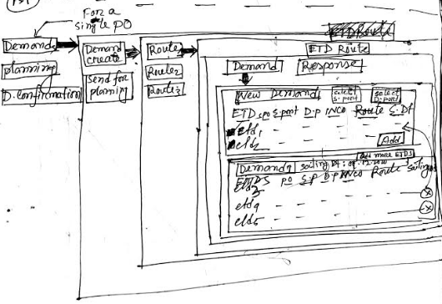

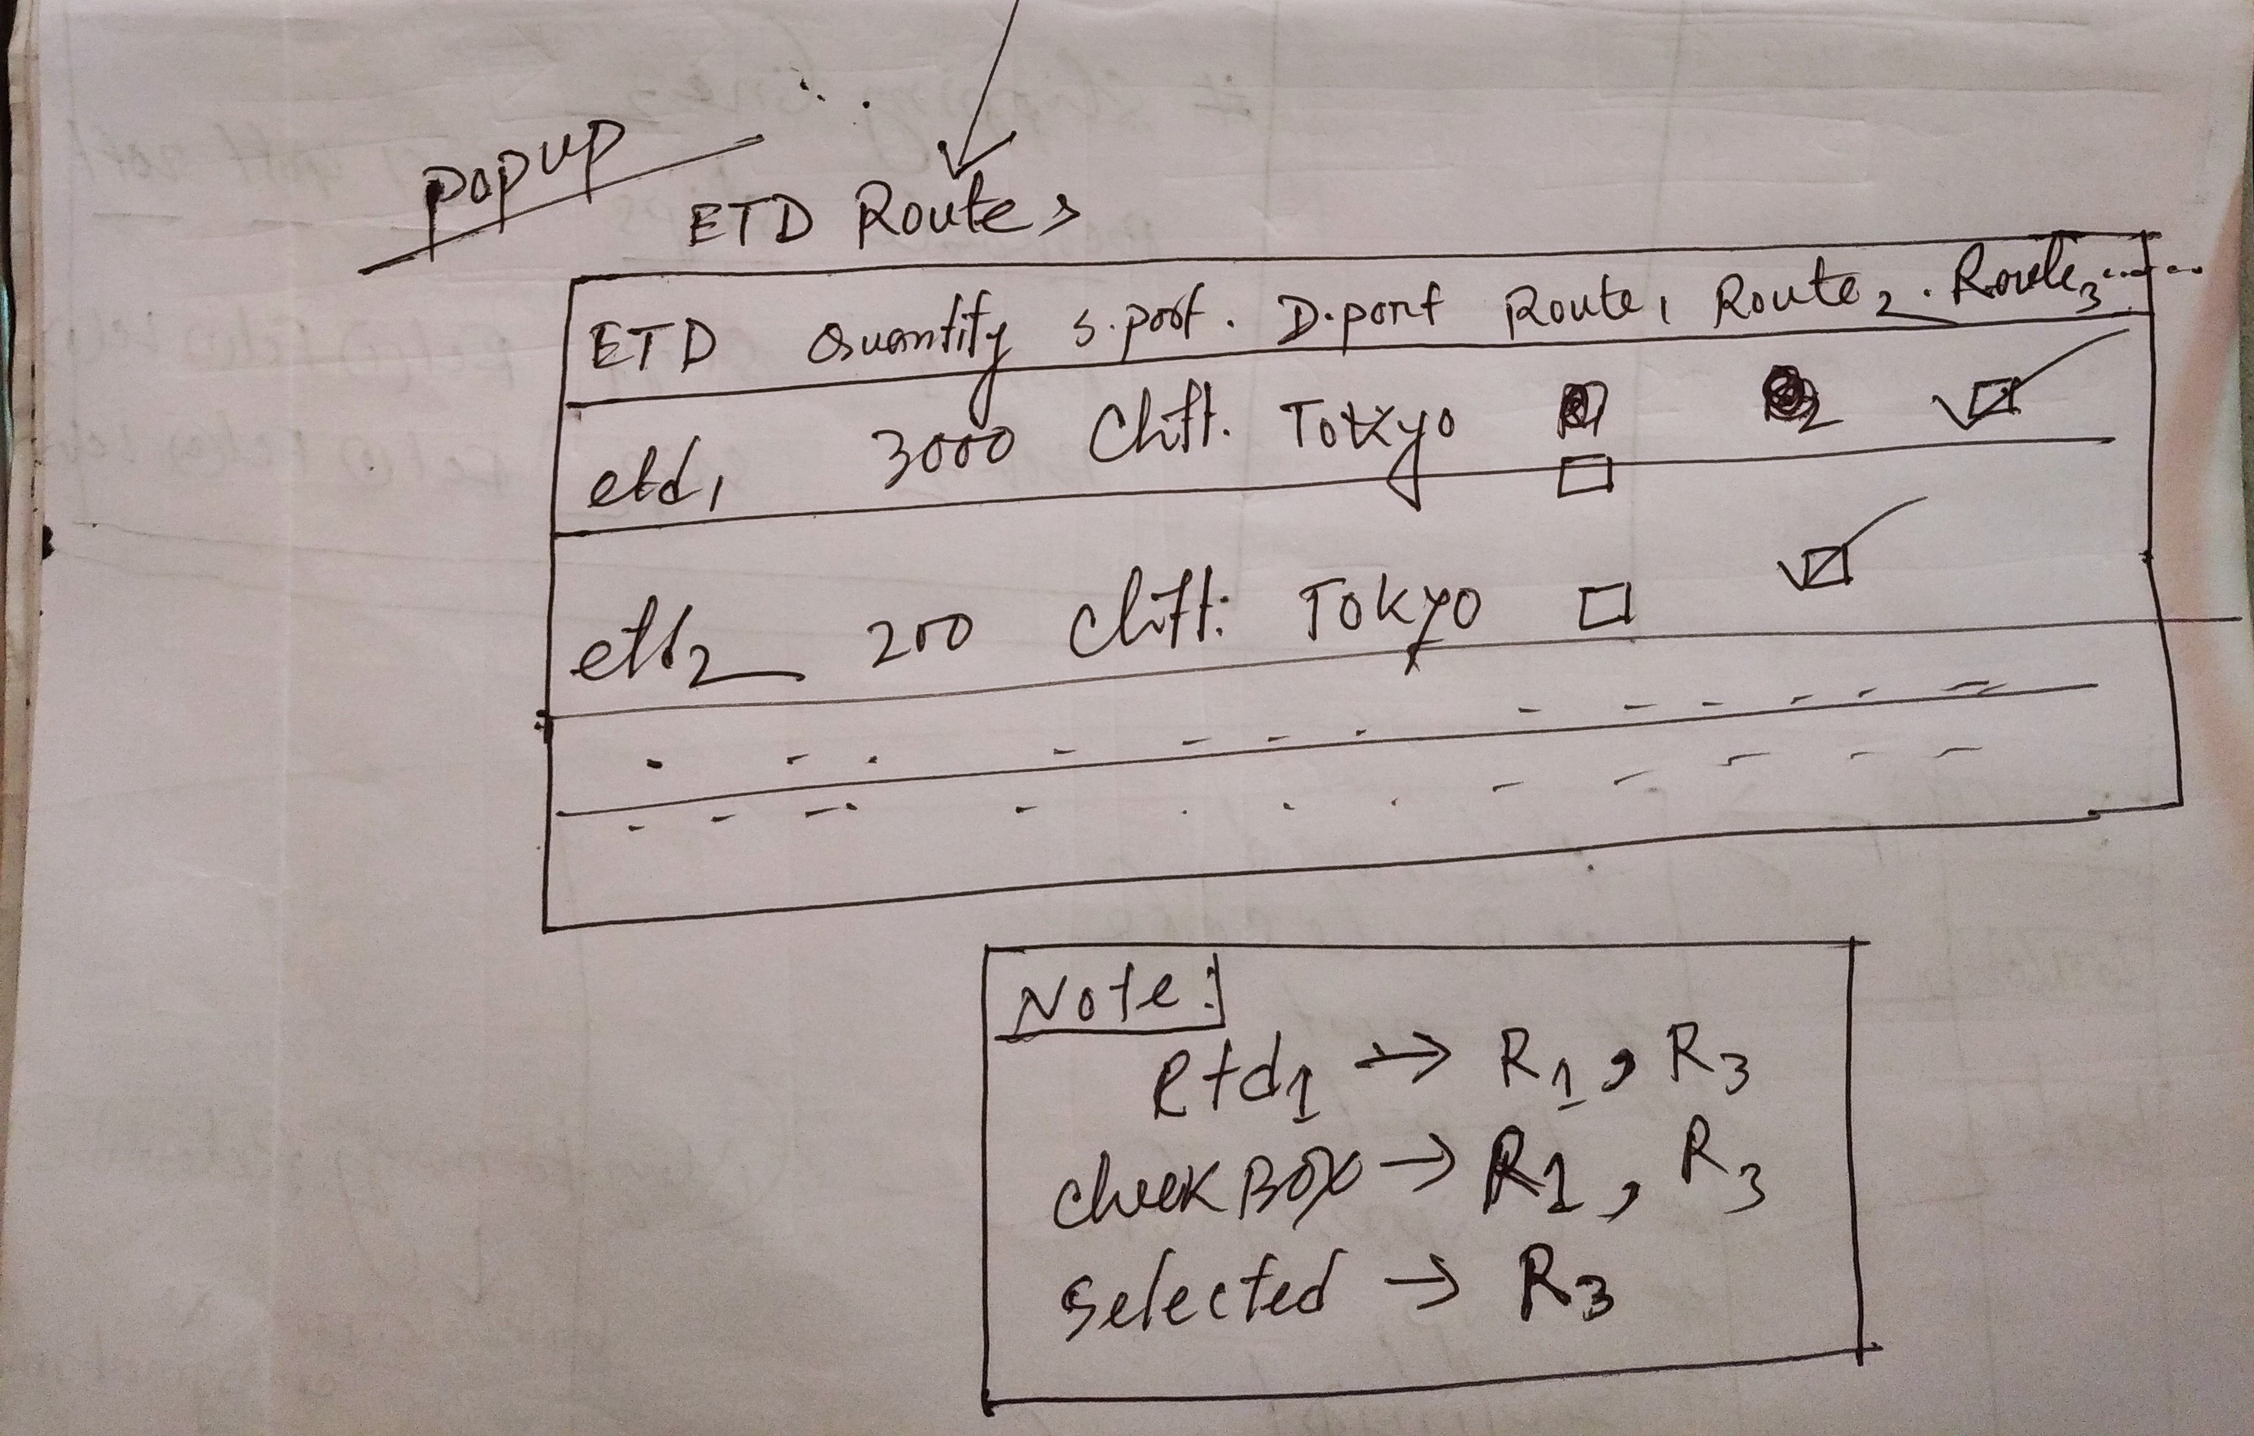

1.2.2 Send for Planning
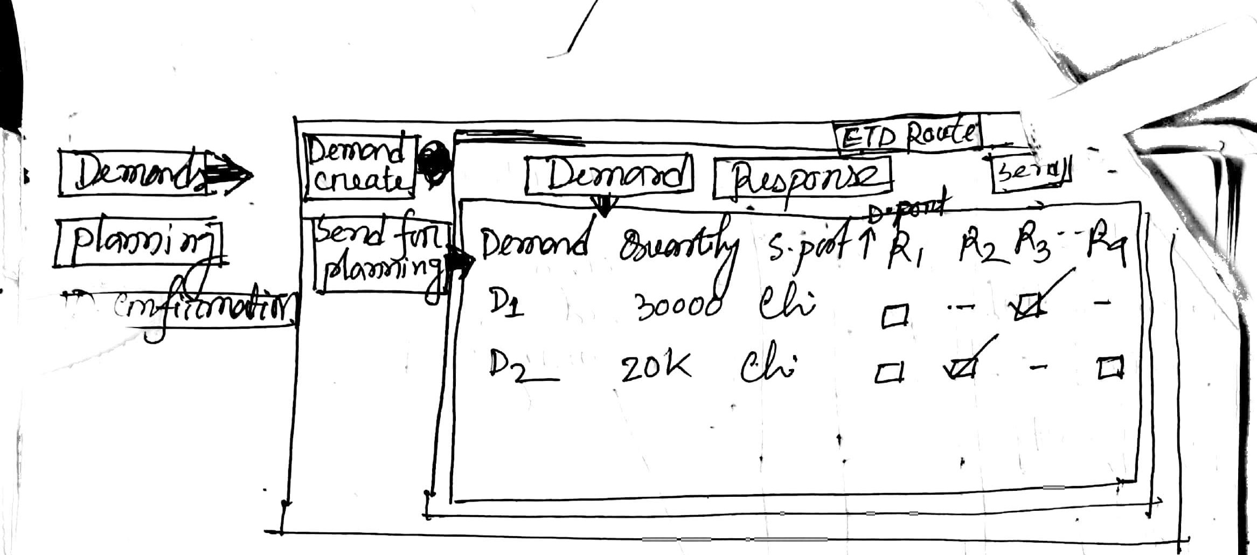

1.3 UI Work Flow
1.3.1 Create Demand Tasks
- List of demands
- Adding more ETDs into demands
- Add new demand
1.3.2 Send for Planning Tasks
- List of demands
- Demands vs Routes matrix view
- Send for planning

1.4 Work Space Routing
Workspace | Routing
Demands (Tab) | Demands (Menu) → Create Demand (Sub menu)→ Route info menu
Demands (Menu) → Send for Planning (Sub menu) | Demands (Tab)

1.5 Expression Table
SN | Title | Content
 | External Dependencies | *routes,*list of etds, *route preference
 | Business Constraints | - Demand will be created for a route and route itself has weekdays  - Sailing date of demand : Selected ETDs → latest sailing date → & selected routing → nearest week deport date  - Add “Add more etds” on the right of demand header so that user can add more etds to a particular demand. Filter etd options based on demand’s s.port,d.port and shipment mode. It’s a popup.  - While creating new demand first take s.port,d.port and shipment mode then show the etds matching the provided s.port,d.port and shipment mode.
 | Technical Constraints
 | Functions | - Prepare Routes and its ETDs  - Fetch PO ETDs  - Fetch routes Prepared Route ETDs based on etd’s sail, destination ports and shipment mode match to the route’s sail,destination,transition ports and shipment mode  - Show the routes with ETDs in route info menu  - Consider only the ETDs of the selected route in creating demands  - Initially create demands based on etd sailing port,etd d.port, etd sailing date and shipment mode( if multiple matches fund , put the etd in the route found from route preference otherwise place it as open etd). So while creating demands group it by route, etd s.port, etd d.port, etd sailing date and shipment mode.
 | Findings | - Route itself has weekdays  - Finding sailing date seems not okay
 | Unexplored Issue
 | Deliverable | - Prepare demands for consignment planning
 | Notes | Landed with PO  Operator: merchandizer  Route card : add→ s.port,d.port,transition port codes,  ETD list : add columns (quantity,sailing date)  Add checkbox to new demand section,  New demand will be created with the selected ETDs, initially all ETDs will be unselected.  Rename booking to bookable
 | Questions
1.6 Operation Flow
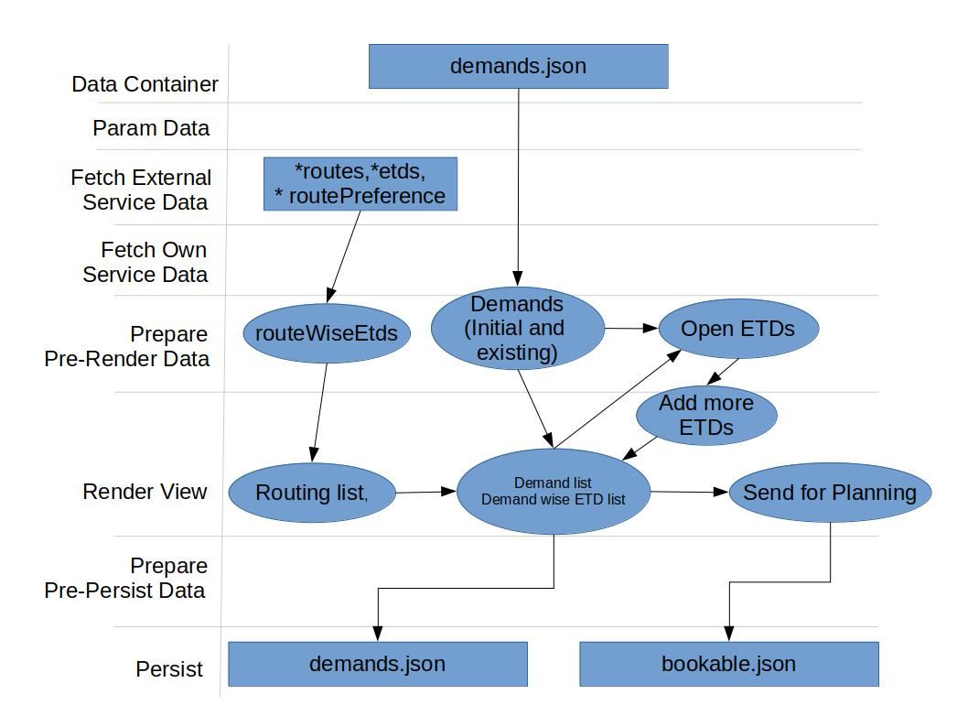

1.7 Data Structure
1.7.1 Mock Data (* Route ,* ETDs and *PreferedRouteMock)
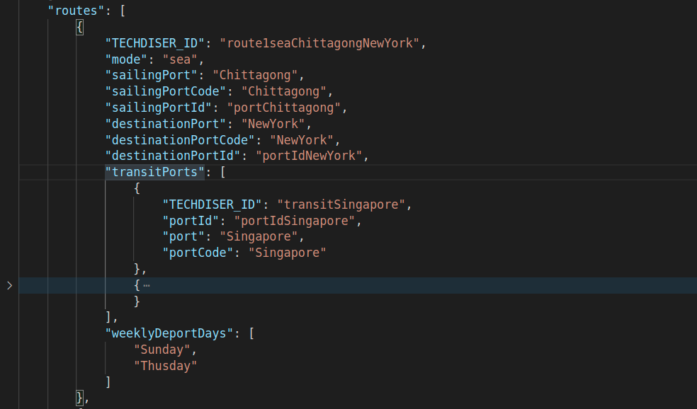

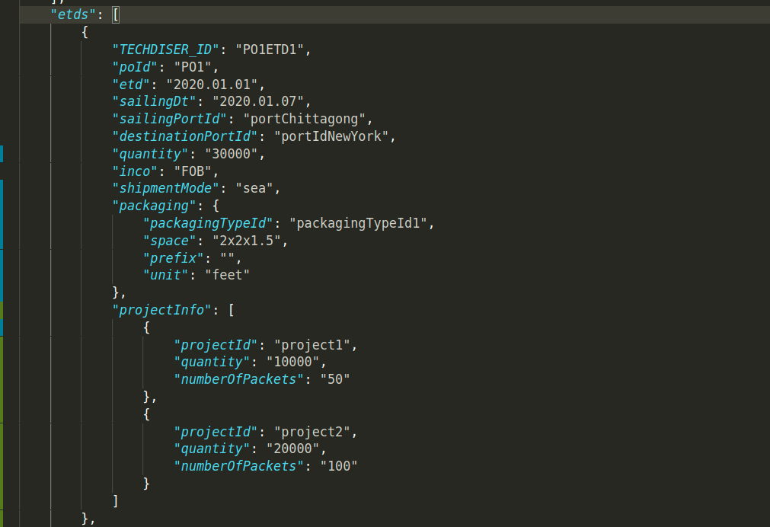

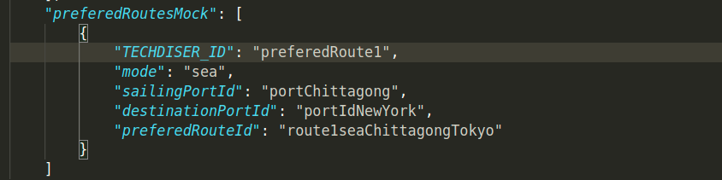

1.8 Data and Data Save Path ( Demand Create)
1.8.1 Save Demands
Task : Demand Create
JSON : demand.json
Path : /
Sample Data :
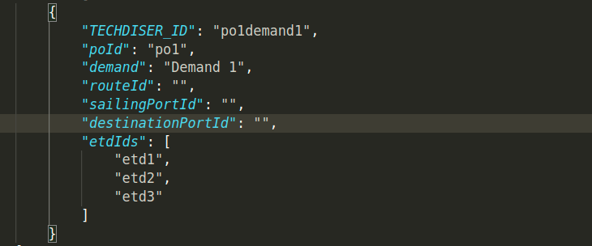

1.8.2 Save Bookables
Task : Send for planning
JSON : bookables.json
Path : /
Sample Data :
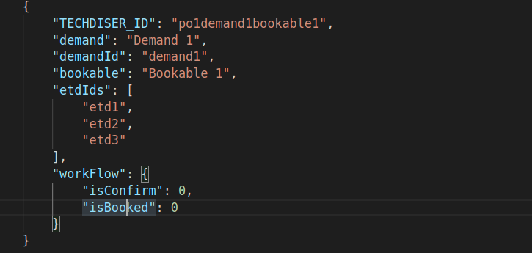

1.9 Derivation:
View Component | UI Routing | Json/Mock | Path
List of Route ( Info menu) | Planning (menu)→ List of Route ( Info menu) | *Route
List of Route ( Info menu) | Planning (menu)→ List of Route ( Info menu) | *ETDs
Create demand (Initial/ existing)

1.10 Technical Workout
Workspace | Components/Controllers | Data fetch | View data  preparation | Event/Operations | In-memory/save  data
List of routes | Route(Info menu) | 1. *route  2. In memory |  |  | In memory
Demand create | List of demands | 1.demand.json/  2. *ETDs | View data preparation for list of demands | Viewing list of demands | demand.json/
Demand create | Add new demand |  |  | Creating new demand | demand.json/
Send for planning | List of demand (send for planning) | 1.demand.json/  2.bookable.json/ | View data preparation for list of demands | Check box for sending demand | bookable.json/

1.11 Time Estimation: Total time 23 hrs / 3 working days
Sl.# | Menu/Sub-menu | Component | Task Hints | Time
1. | Demand Create (Sub menu) | Info men | Mock data prepare (Route,etds,shipping lines) ,List of routes | 3 hrs
1. | Demand Create (Sub menu) | Demand creates | Filter demand using s.port and d.port | 2 hrs
1. | Demand Create (Sub menu) | Remove ETDs from demand | Remove etds and reassign to (?) | 0 hrs
1. | Demand Create (Sub menu) | Create new demand | Filtered by s.port, d.port | 1 hrs
1. | Demand Create (Sub menu) | Response tab (all) |  | 3 hr
1. | Demand Create (Sub menu) | Etd Route (popup) | Route vs ETD matrix | 3 hr
2. | Send for planning (sub menu) | Route vs demand matrix |  | 2 hr
3. |  | Common services and other stuffs | Mgt services, data services,  id gen for demand.json and bookable.json | 1 working day

Chapter 2 : Planning
2.1 Steps and Goals: ( Planning)
SN | Steps | Sub-Goals | Section
1. | - Calendar view | Planning | Section 2
2. | - Viewing demands with response (demand tab)  - Viewing ship wise bookables (shipping lines tab)  - Assigning bookable into ship (Demand Pos. popup)  - Splitting demand (Split demands popup)  - Viewing all demand as per shipping line (All demands popup)  - Ship and container wise FCL and LCL counting (Containers)  - Bookable positioning into FCL (DemandPos.(FCL))  - Bookable positioning into LCL | Planning | Section 2
2.2 UI
2.2.1 Planning UI
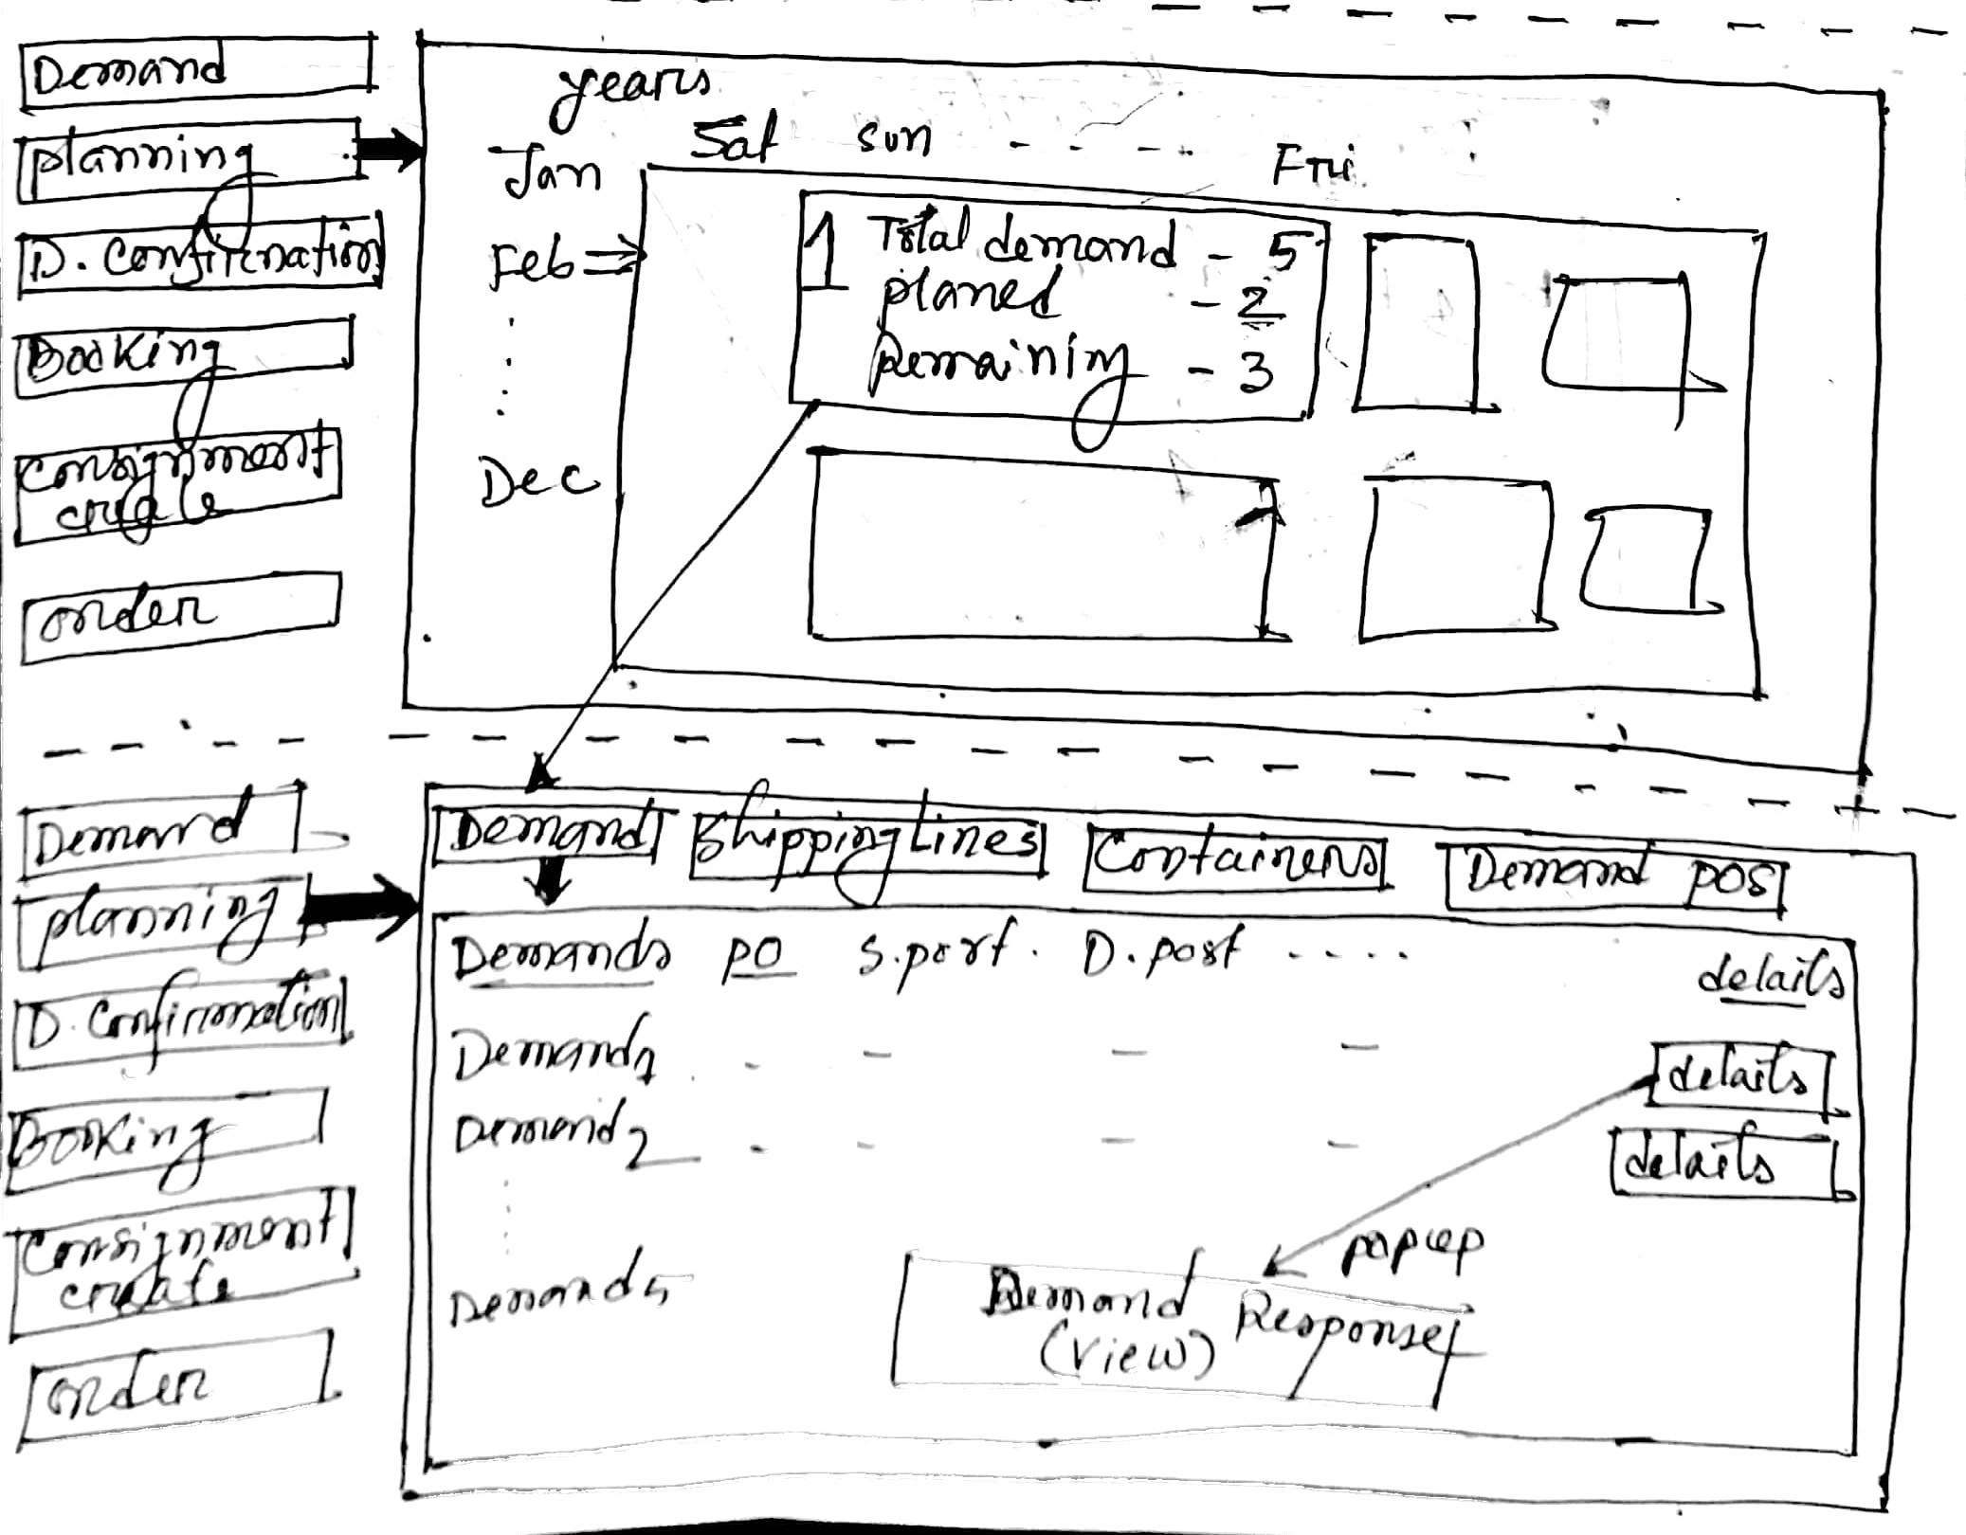
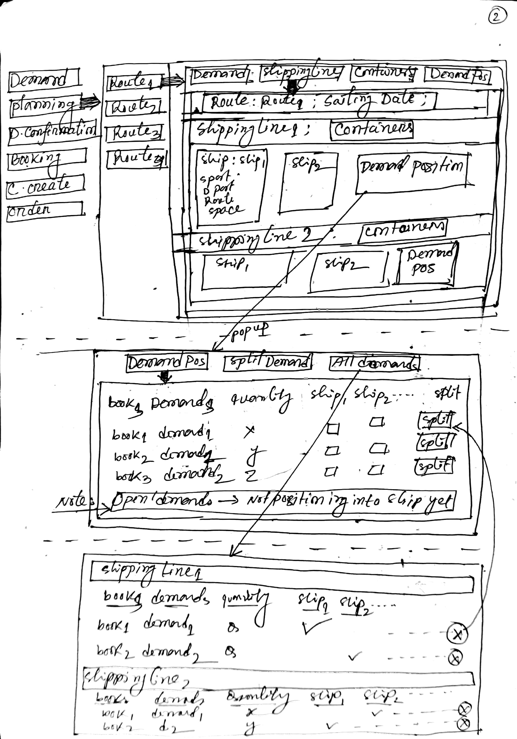
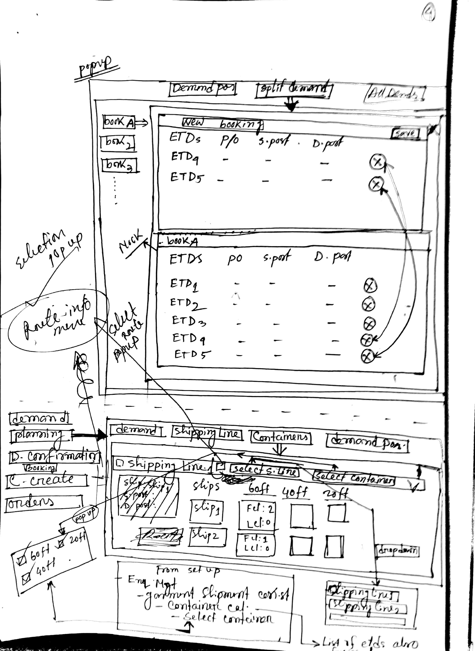
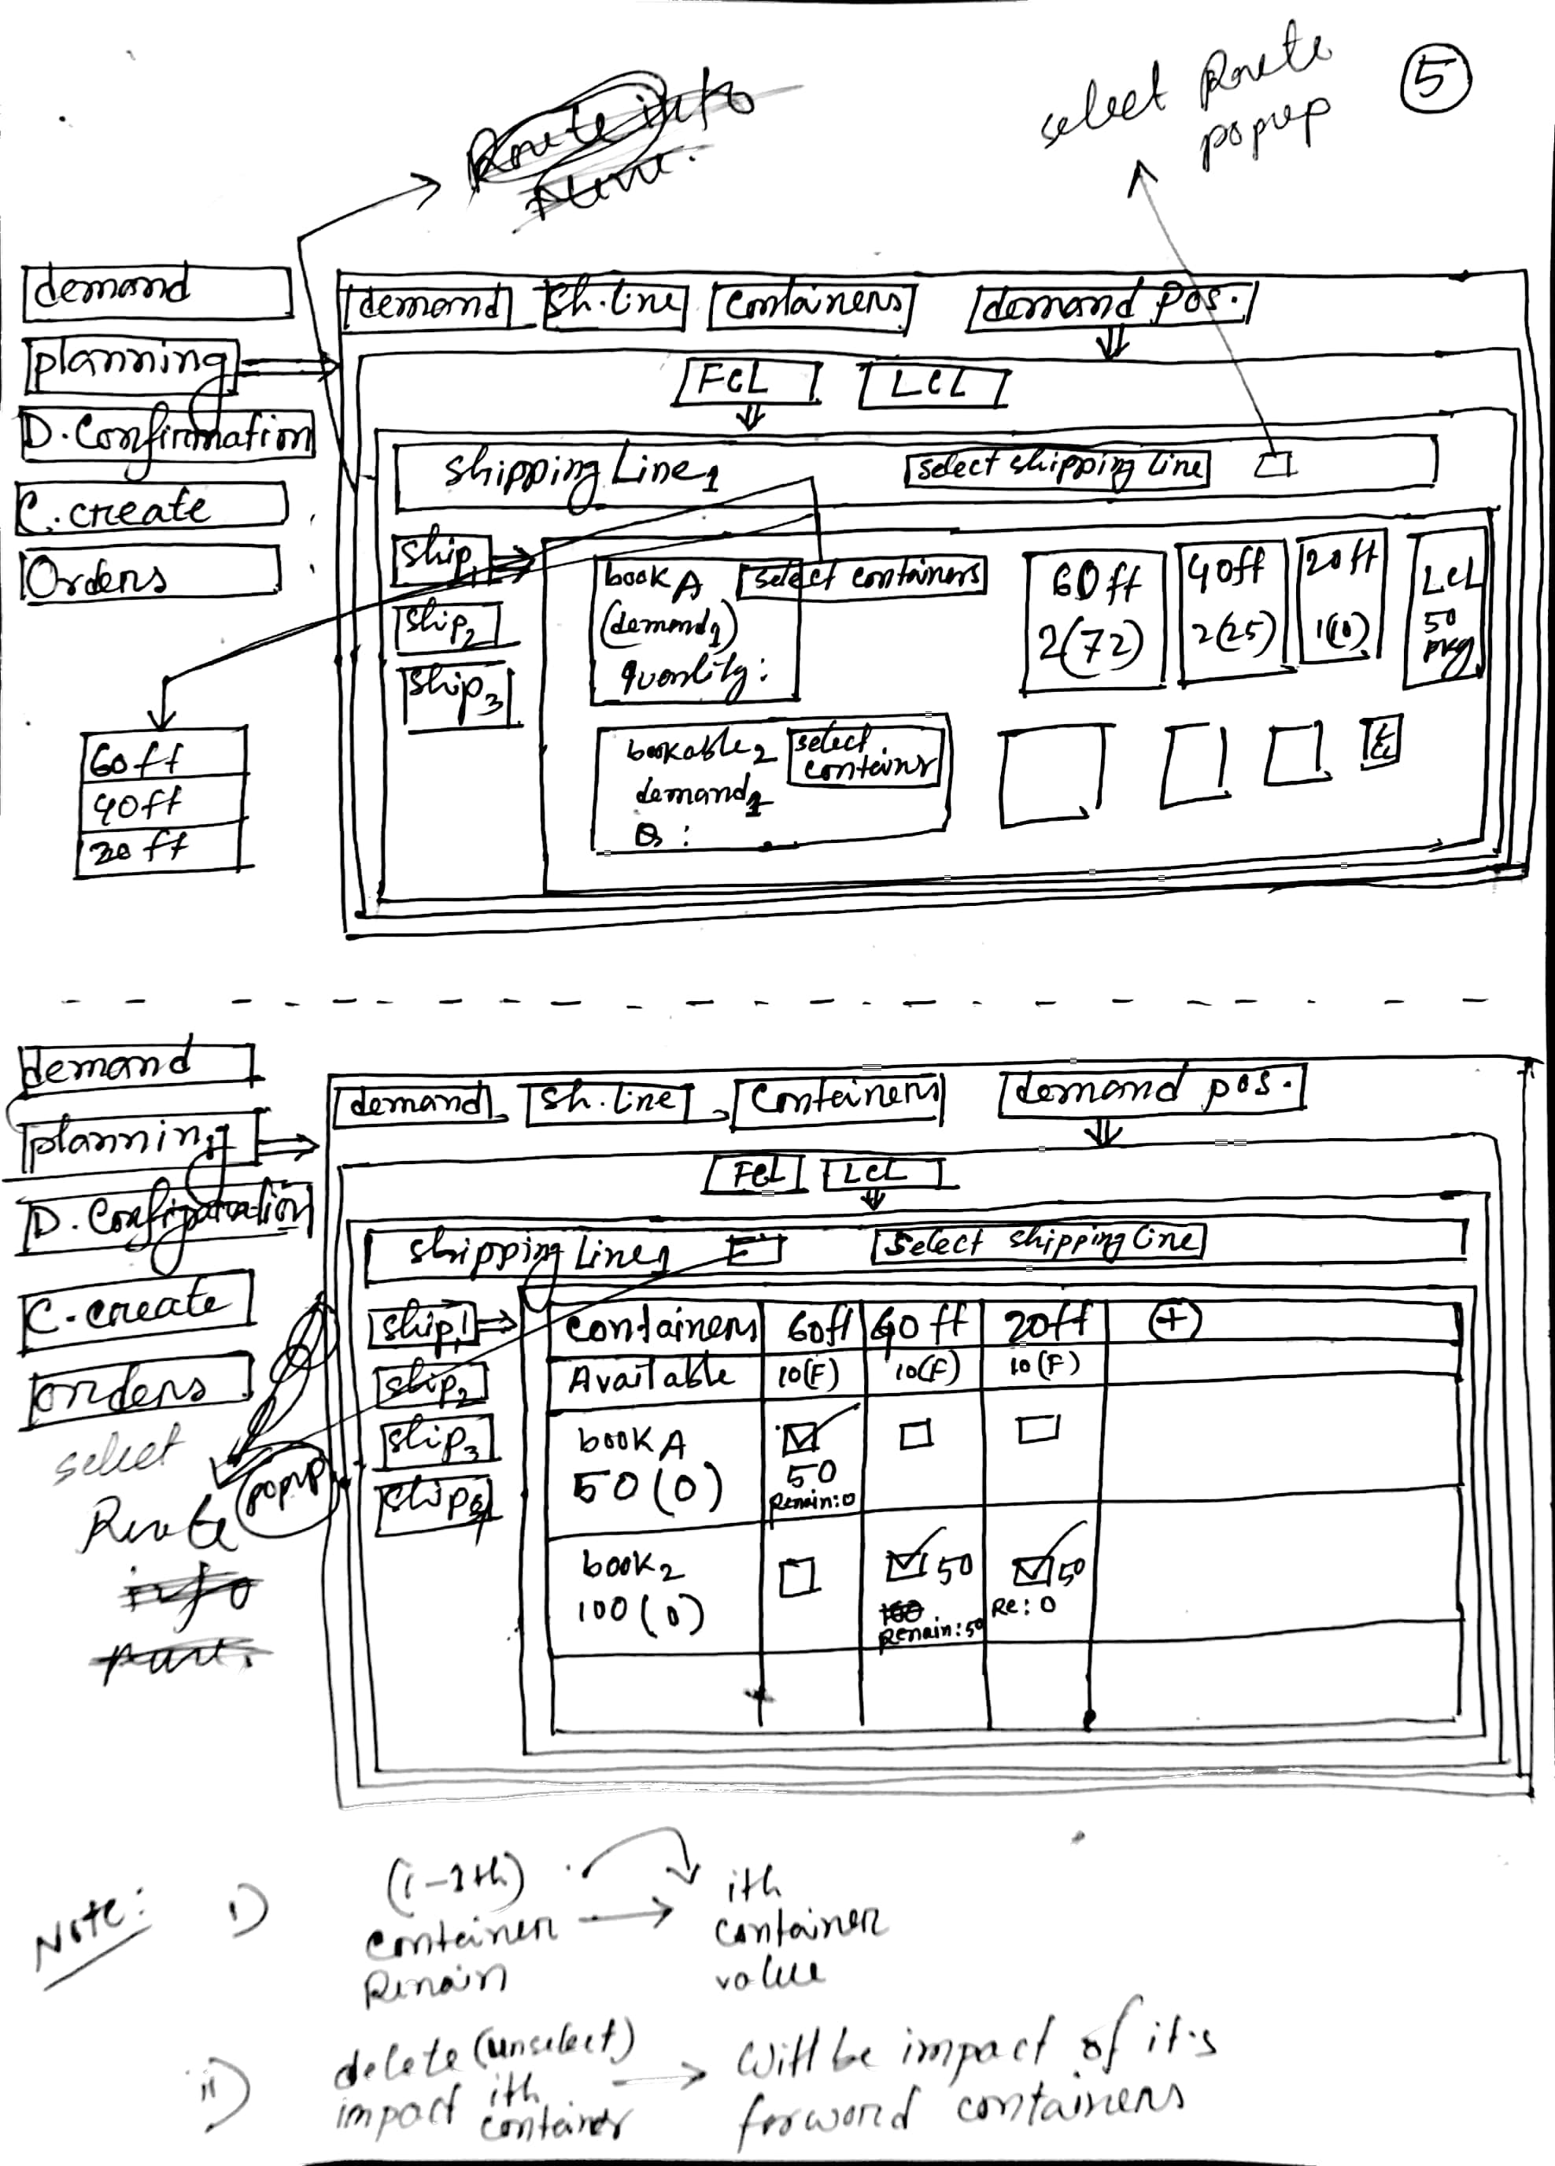

2.3 UI Work Flow
2.3.1 Calendar view Tasks (Planning→Landing Page-Calendar)
- Total demands
- Planned
- Remained
2.3.2 View demands with response Tasks (Planning→demand tab)
- List of demands(with PO & route code)
- Demand response details
2.3.3 View ship wise bookables Tasks (Planning→shipping lines tab)
- List of routes
- List of shipping lines
- Demand positioning into ship(popup)
- switch to container tab for this shipping line
2.3.4 Assigning bookable into ship Task (Planning→Demand Pos. popup))
- List of bookable(open demands)
- Bookable ( open bookables) vs ship matrix
- list of ships for a specific shipping line
- Assigning bookable into ship
- Switch to split demand tab
2.3.5 Splitting demand Tasks (Planning→Split demands popup)
- List of bookable
- Positioning ETD into bookable
2.3.6 Viewing all demand (Shipping line wise) Task (Planning→All demands popup)
- List of shipping lines
- List of bookable
- List of ships for a specific shipping line
2.3.7 Ship and container wise FCL and LCL counting Task (Planning→Containers)
- Select route(popup)
- Select shipping line(drop down)
2.3.8 Bookable positioning into FCL (max level packing wise) Tasks (Planning→DemandPos.(FCL))
- Select route(popup)
- Select shipping line(drop down)
- List of ships for a specific shipping line
- List of bookable for a specific ship
2.3.9 Bookable positioning into LCL (max level packing wise) Tasks (Demand→Confirmation)
- List of bookable
- Confirm demand
2.4 UI Routing
2.4.1 Planning→Landing Page-Calendar
- Planning → Calender
2.4.2 Planning→demand tab
- Planning → List of tabs(horizontally)→ Demands(tab)
2.4.3 Planning→shipping lines tab
- Planning → List of tabs(horizontally)→ ShippingLines(tab)→ List of routes → ShippingLines
2.4.4 Planning→Demand Pos. popup
- Planning → List of tabs(horizontally)→ ShippingLines(tab)→ List of routes → ShippingLines
- Demand positioning(popup)→ List of tabs→ Demands tab(Selected)

2.4.5 Planning→Split demands popup
- Planning → List of tabs(horizontally)→ ShippingLines(tab)→ List of routes → ShippingLines
- Demand positioning(popup)→ List of tabs(horizontally)→ Split Demand→ List of bookable
2.4.6 Planning→All demands popup
- Planning → List of tabs(horizontally)→ ShippingLines(tab)→ List of routes → ShippingLines
- Demand positioning(popup)→ List of tabs(horizontally)→ All Demand→ List of shipping lines
2.4.7 Planning→Containers
- Planning → List of tabs(horizontally)→ Containers(tab)→ Select routes → Select ShippingLines
2.4.8 Planning→DemandPos.(FCL)
- lanning → List of tabs(horizontally)→ Demand Pos.(tab)→ FCL(tab)→ Select routes → Select ShippingLines→ List of ships

2.5 Expression Table
SN | Title |  | Content
 | External Dependencies |  | Bookables
 | Business Constraints |  | - Landing page is a calendar . Bookables will be filtered based on calendar date (matching with sailing date ).  - Bookable will be read for multiple PO  - In demand pos. tab : List of open bookable those are not positioned into ship yet
 | Technical Constraints | Planning(landing page) | demand will be read for all PO and all routes( demand tab)
 | Technical Constraints | demand(tab)
 | Technical Constraints | ShippingLine→Demand Pos.(pop up) | List of bookable (Open) that means those demands which haven’t positioned yet into ship.
 | Technical Constraints | ShippingLine→Split Demand (pop up) | Q. when split bookable will be updated ?  Q. what is the policy of undoing split?
 | Technical Constraints | Planning→  Container (tab) | All space will be measured into feet (Container & Packet)
 | Technical Constraints | FCL (tab)
 | Technical Constraints | LCL (tab)
 | Functions | Planning(landing page)
 | Functions | demand(tab)
 | Functions | ShippingLine→Demand Pos.(pop up)
 | Functions | ShippingLine→Split Demand (pop up)
 | Functions | Planning→  Container (tab)
 | Functions | FCL (tab)
 | Functions | LCL (tab)
 | Findings
 | Unexplored Issue
 | Deliverable |  | Prepare demands for planning

2.6 Operation Flow
Demand list view | Positioning bookable to ship
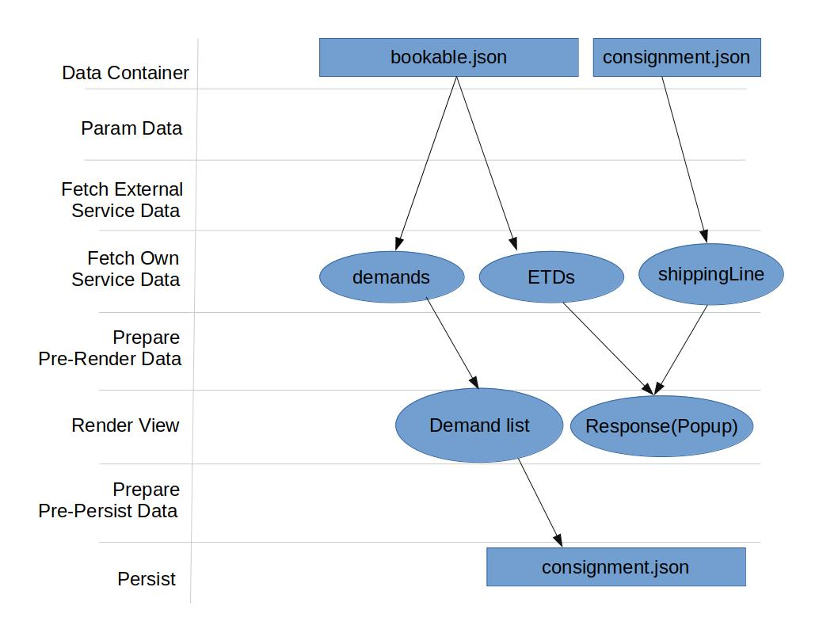 | 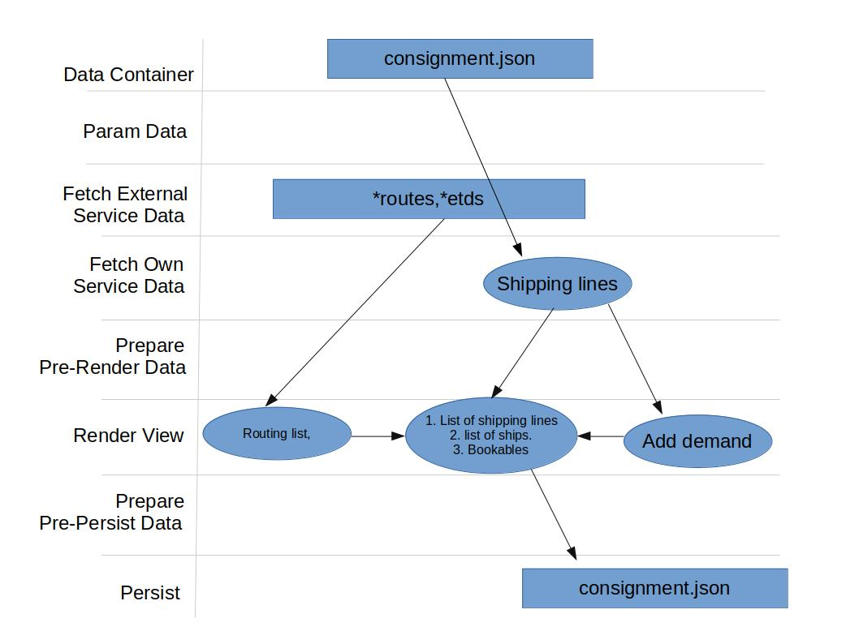
Packet positioning into FCL | Packet positioning into LCL
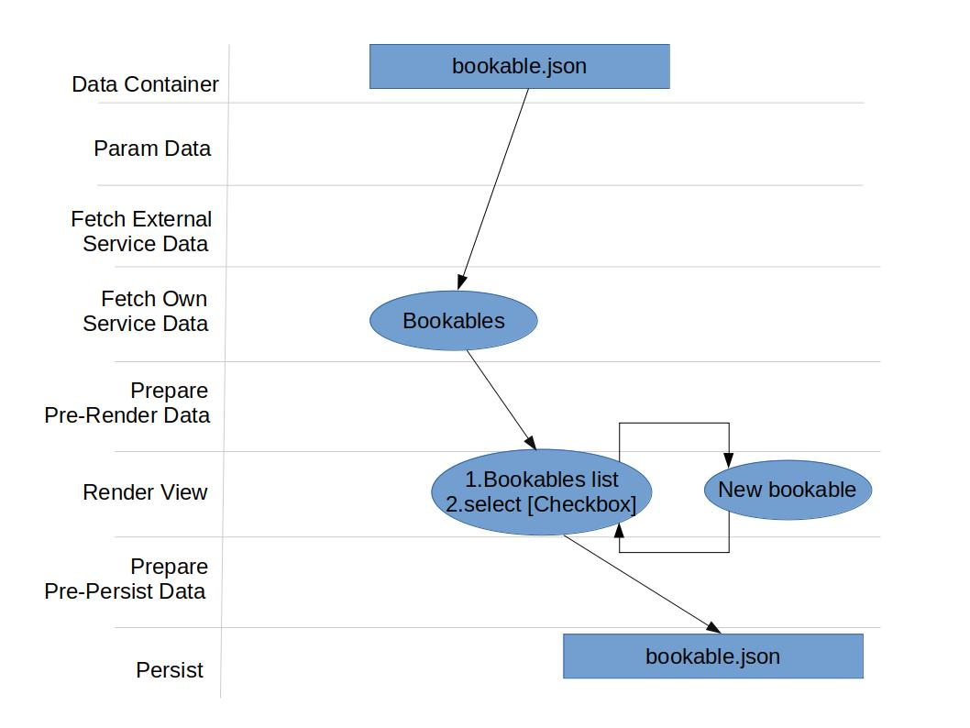 | 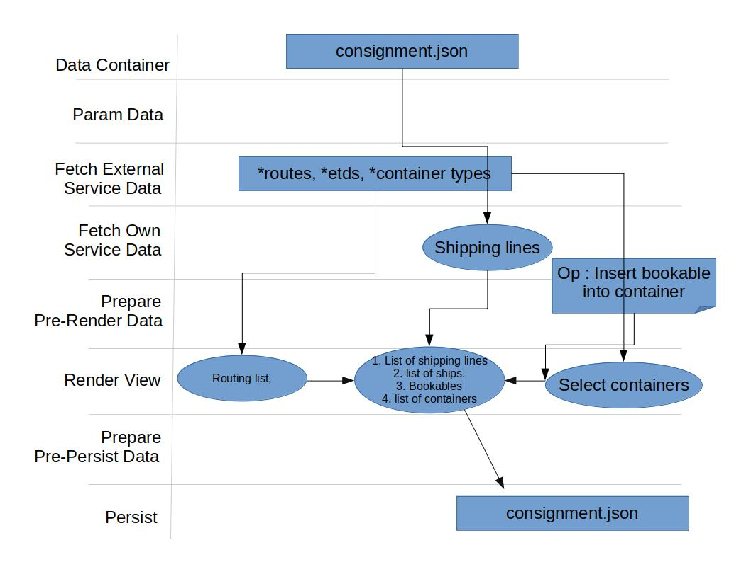

2.7 Data Structure
2.7.1 Mock Data
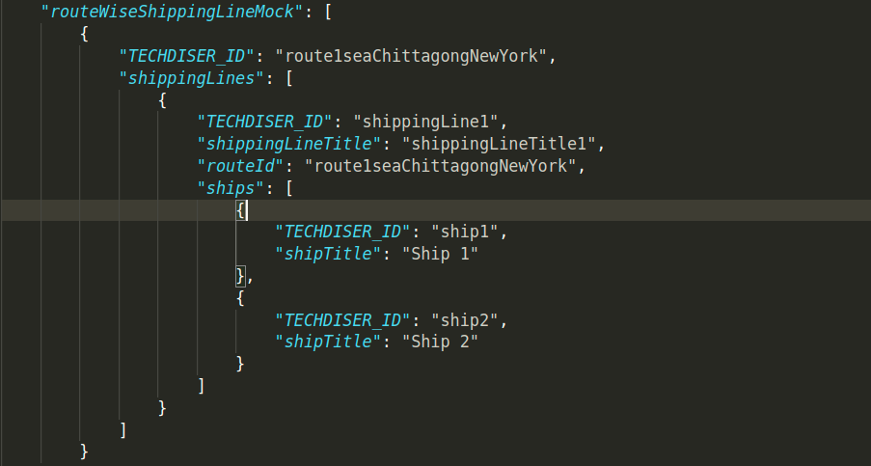

2.7.2 Final Data Structure (Planning)
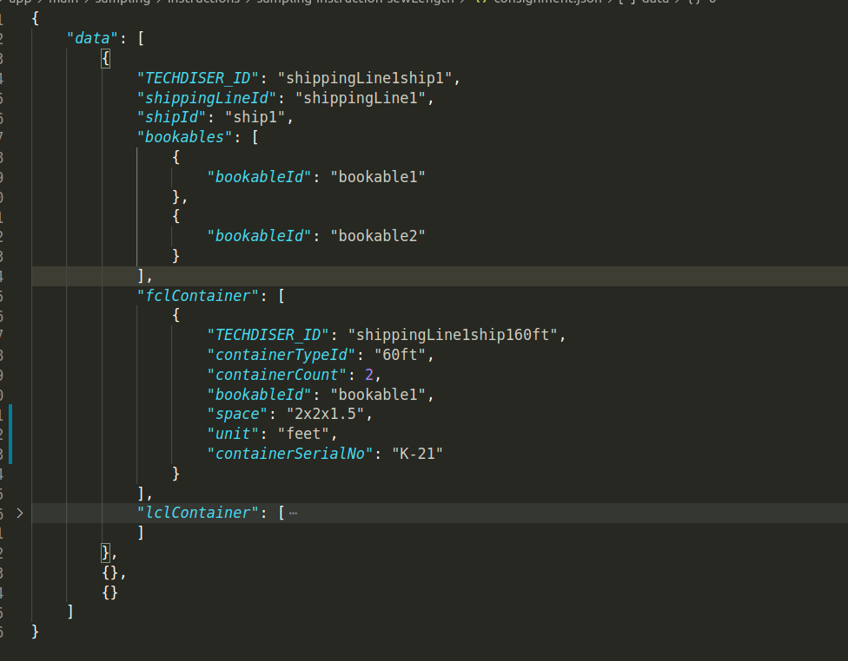

2.8 Derivation:
View Component | UI Routing | Json | Path
calendar | Planning→ calendar | bookable.json | bookable.json/
List of bookables | Planning→ demand tab | bookable.json | bookable.json/
Demand response | Planning→ demand tab | consignment.json | consignment.json/
List of routes | Planning→ shipping line tab | *routes | *route/
List of shipping lines | Planning→ shipping line tab | *routes | *routes/shippingLines
List of ships | Planning→ shipping line tab→ DemandPos. tab(popup) | *routes | *routes/shippingLines/  ships
Select container type(popup) | Planning→ Container tab | *containerType | *containerType/

2.9 Data Flow Diagram (DFD)
2.9.1 Data and Data Save Path
Task : Planning→ Shipping Line (tab)
JSON : consignment.json
Path : /
Sample Data :
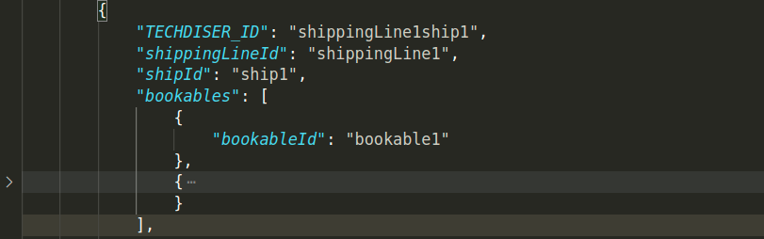

2.9.2 Data and Data Save Path
Task : Planning→ Shipping Line→ Split demand (Pop up)
JSON : bookable.json
Path : /
Sample Data :
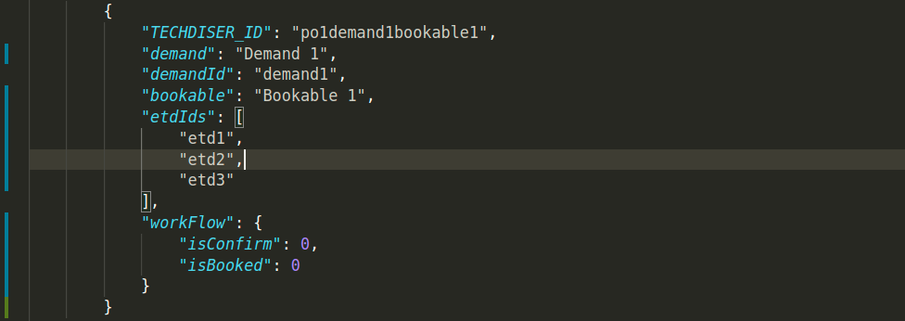

2.9.3 Data and Data Save Path
Task : Planning→ Containers
JSON : consignment.json
- Path : /[id]/fclContainer
- Path : /[id]/lclContainer
Sample Data :
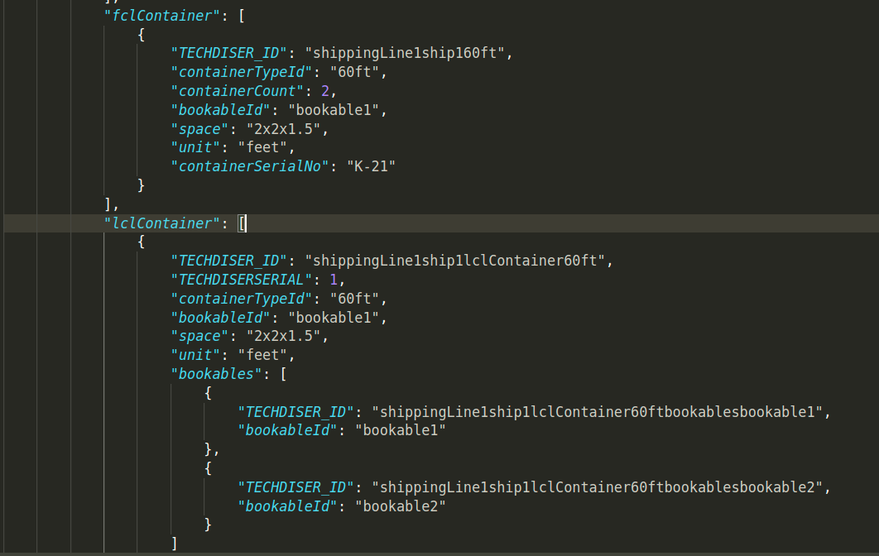

2.9.4 Data and Data Save Path
Task : Planning→ Demand Pos.→FCL
JSON : consignment.json
- Path : /[id]/fclContainer
Sample Data :
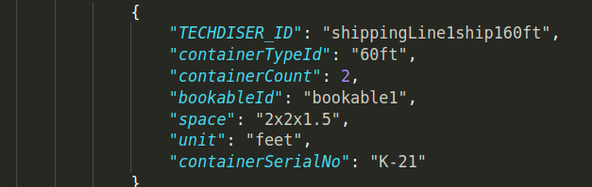

2.9.5 Data and Data Save Path
Task : Planning→ Demand Pos.→LCL
JSON : consignment.json
- Path : /[id]/lclContainer
Sample Data :
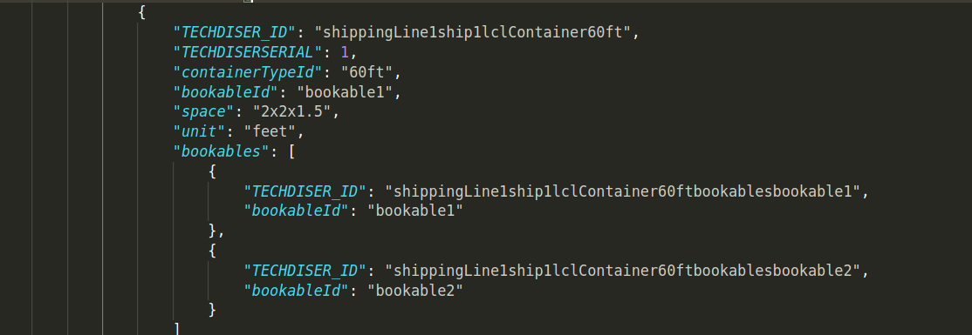

2.10 Technical Workout
Workspace | Components/Controllers | Data fetch | View data  preparation | Event/Operations | In-memory/save  data
planning(landing page) | calendar | bookable.json/ | View data preparation for calendar | Viewing total demands | In memory
planning(demand tab) | List of bookable | 1.bookable.json  2.consignment.json/ | View data preparation for list of bookable |  | consignment.json/
planning(demand tab) | Button(details) | consignment.json/ | View data preparation for response | popup | In memory
planning(shipping line tab) | List of routes | 1. *route | View data preparation for list routes | view list of shipping lines for onClick event | In memory
planning(shipping line tab) | List of shipping lines | 1.*routes/shippingLines | View data preparation for list of shipping lines | view list of ships for onClick event | In memory
planning(shipping line tab) | List of ships & container info | 1.consignment.json/fclContainer  2.consignment.json/fclContainer | View data preparation for list of ships |  | 1.consignment.json/fclContainer  2.consignment.json/fclContainer
Planning→ shipping line tab→ DemandPos. tab(popup) | List of bookable | bookable.json/ | View data preparation for list of bookable |  | In memory
Planning→ shipping line tab→ DemandPos. tab(popup) | List of ships | 1.*routes/shippingLines/  ships | View data preparation for list of ships | Bookable allotment into ship | In memory
Planning→ shipping line tab→ DemandPos. tab(popup) | Insert bookable into ship |  |  | Check On | 1.consignment.json[id(shippingLine)]/bookables
Planning→ shipping line tab→ Split demand tab(popup) | List of bookable | bookable.json/ |  | Split bookable | bookable.json/
Planning→ shipping line tab→ All demand tab(popup) | List of shipping line | consignment/shippingLines/shippingLines |  |  | consignment/planning /shippingLines/shippingLines
Planning→ shipping line tab→ All demand tab(popup) | List of bookable | consignment.json/bookables |  |  | In memory
Planning→ shipping line tab→ All demand tab(popup) | List of ships | consignment.json/ |  |  | In memory
Planning→ Container Tab | Select route(popup) | 1. *route | View data preparation for route | Select route | In memory
Planning→ Container Tab | Select shipping line(drop down) | 1.consignment.json | View data preparation for shipping line | Select shipping line | In memory
Planning→ Container Tab | Select container type(popup) | 1.*containerType/ | View data preparation for container type | Select container type | In memory
Planning→ Container Tab | Ship wise container type count | 1.consignment.json/fclContainer  2.consignment.json/fclContainer | View data preparation for list of ships wise container count | Create FCL and LCL container | 1.consignment.json/fclContainer  2.consignment.json/fclContainer
Planning→ Demand Pos. Tab | Select route(popup) | 1. *route | View data preparation for route | Select route | In memory
Planning→ Demand Pos. Tab | Select shipping line(drop down) | 1.consignment.json | View data preparation for shipping line | Select shipping line | In memory
Planning→ Demand Pos. Tab | Select container type(popup) | 1.*containerType | View data preparation for container type | Select container type | In memory
Planning→ Demand Pos. Tab | List of ships | consignment.json/ |  |  | In memory
Planning→ Demand Pos. Tab | List of bookable | consignment.json/bookables |  |  | In memory
Planning→ Demand Pos. Tab | Bookable positioning (FCL Tab) | 1.consignment.json/fclContainer/[container id] |  | Insert bookable into FCL container | 1.consignment.json/fclContainer/[container id]
 | Bookable positioning (LCL Tab) | 1.consignment.json/lclContainer/[container id] |  | Insert bookable into LCL container | 1.consignment.json/lclContainer/[container id]

2.11 Time Estimation: Total time 31 hrs / 4 working days
Sl.# | Menu/Sub-menu | Component | Task Hints | Time
1. | Planning (Menu) →  Calendar | Calendar view | Prepare calendar and data preparation | 4hr
2. | Planning (Menu) →  Demand (Tab) | Demand list with response view | Demand list with response view | (1.5 + 2) hr
3. | Planning (Menu) →  Shipping line (Tab) | Info menu (Route), shipping line work space |  | 3 hr
4. | Planning (Menu) →  Shipping line (Tab) → demand pos(tab) | Demand pos. tab | Ship vs bookable matrix, assigning bookable into ship | 4 hr
5. | Planning (Menu) →  Shipping line (Tab) → Split demandtab) | Split demand tab | Info menu (Bookables), create new bookable, | 2.5 hr
6. | Planning (Menu) →  Container (Tab) | Containers tab | Select route drop down, select shipping line drop down, ship wise container view | 3hr
7. | Planning (Menu) →  Demand pos. (Tab) | FCL tab | Select route & select shipping line drop down, info menu ( ship), bookable card,select container drop down, convert quantity to max level packet and insert into container | 5hr
8. | Planning (Menu) →  Demand pos. (Tab) | LCL tab | Select route & select shipping line drop down, info menu ( ship), bookable card,add container, calculate residue, convert quantity to max level packet and insert into container ,calculate remaining | 5hr
9. |  | Id for consignment and data preparation |  | 1hr

Chapter 3 : Consignment Booking

3.1 Steps and Goals: (Consignment Booking)
SN | Steps | Sub-Goals | Section
1. | - Calendar view | Landing Page | Section - 3
2. | - Viewing bookables with booking response | Booking Confirmation (Tab) | Section - 3
3. | - Viewing bookable vs ship matrix | Confirm Booking ( Tab) | Section - 3
4. | - Container coding | Providing Container Code | Section - 3
5. |  |  | Section - 3

SN | Steps | Goals | Section
- List of demands
Confirmation booking response (Pop up)
 | - List of demands  - Confirmation booking response (Pop up) | Booking confirmation | Section -3
 | - Select route  - Select shipping line  - Bookable vs ship matrix | Confirm booking | Section -3
 | - Select route  - Select shipping line  - List of ship  - Containers list  - Container naming | Providing container name | Section -3

3.2 UI Work Flow
3.2.1 Calendar view tasks ( Landing Page)
- Received demand
- Booked demands
- Remaining demand

3.2.2 Viewing demand with booking response tasks ( Booking Confirmation)
- List of demand
- Viewing demand with booking response
- Confirmation booking response
3.2.3Viewing bookable vs ship matrix tasks ( Confirm Booking)
- Select route
- Select shipping line
- Bookable and ship matrix
- Selected ship for bookables
3.2.4 Container coding tasks ( Containers)
- Select route
- Select shipping line
- List of ships
- List of containers
- Input container code
3.3 UI Routing
3.3.1 UI Routing ( Confirmation )
- Booking→ Confirmation (Tab)
3.3.2 UI Routing ( Confirm Booking)
- Booking→ Confirm booking(Tab)
3.3.3 UI Routing ( Containers)
- Booking→ Containers(Tab)
3.3.4 Consignment Booking →Confirmation UI

3.4 UI
3.4.1 Consignment Booking → Confirmation UI
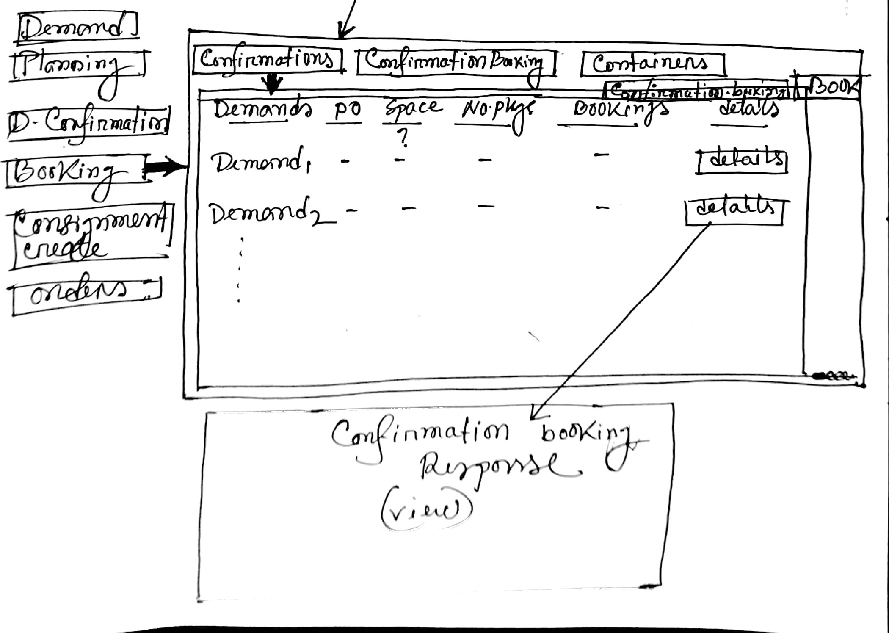

3.4.2 Consignment Booking → Confirmation Booking UI
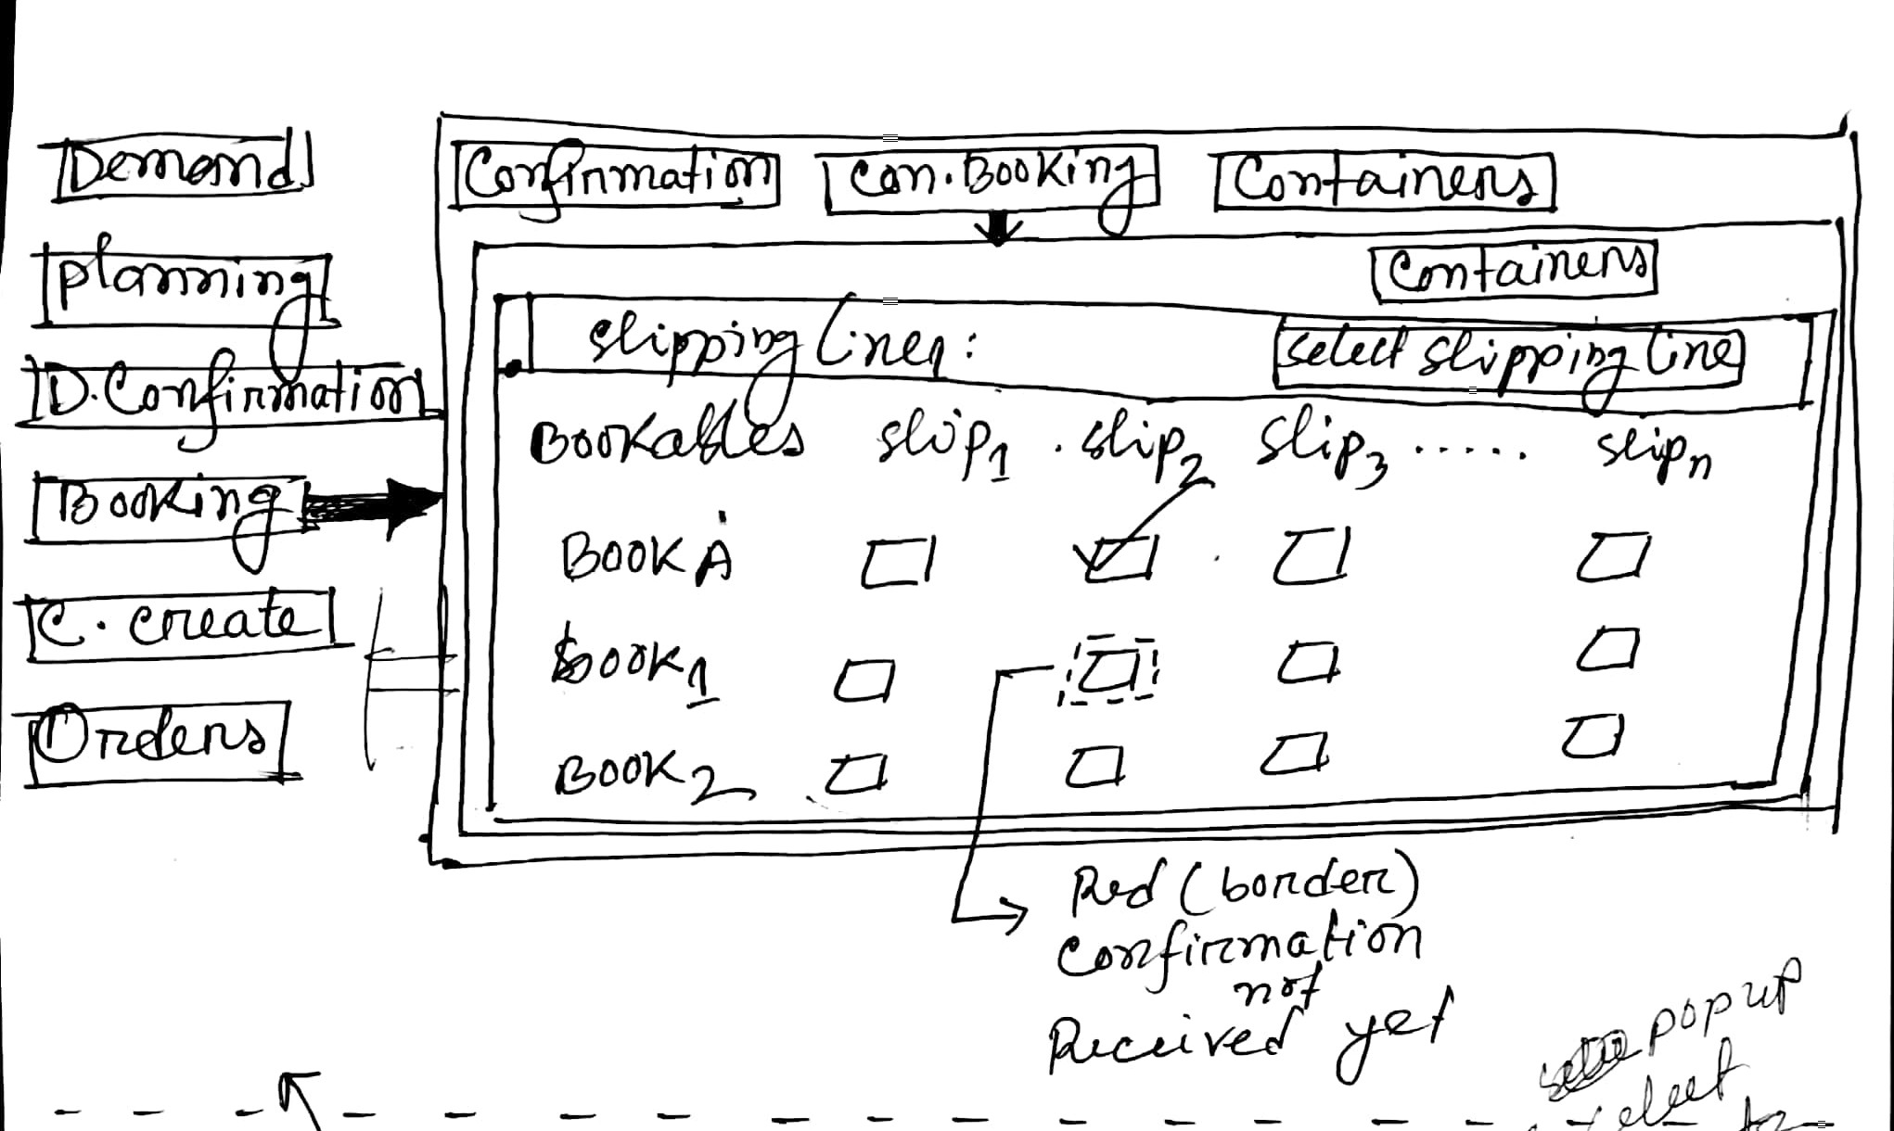

3.4.3 Consignment Booking → Containers UI
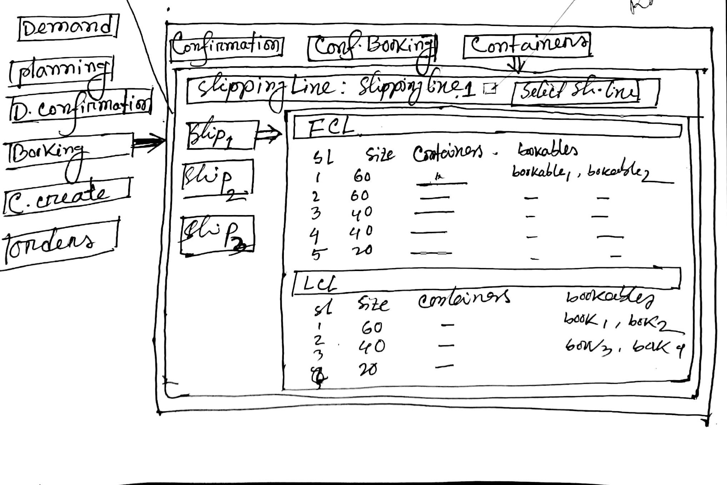

3.5 Expression Table
SN | Title | Content
 | External Dependencies | *routes, * projects
 | Business Constraints | - In booking confirmation tab, border will be red of item of bookable-ship matrix
 | Technical Constraints
 | Functions
 | Findings
 | Unexplored Issue
 | Deliverable | Containers
 | Notes

3.6 Data Structure
3.6.1 Mock Data
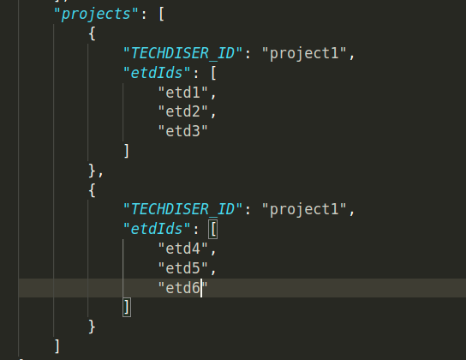

3.7 Derivation:
View Component | UI Routing | Json | Path
List of bookables | Booking →  Confirmation | bookable.json | bookable.json/
Confirmation booking response | Booking →  Confirmation | consignment.json | consignment.json/
List of routes | Booking →  Confirm Booking | *route | *route/
Select shipping line(drop down) | Booking →  Confirm Booking | consignment.json | consignment.json/[id]/
3.8 Operation Flow
3.8.1 Operation Flow ( Confirmation)
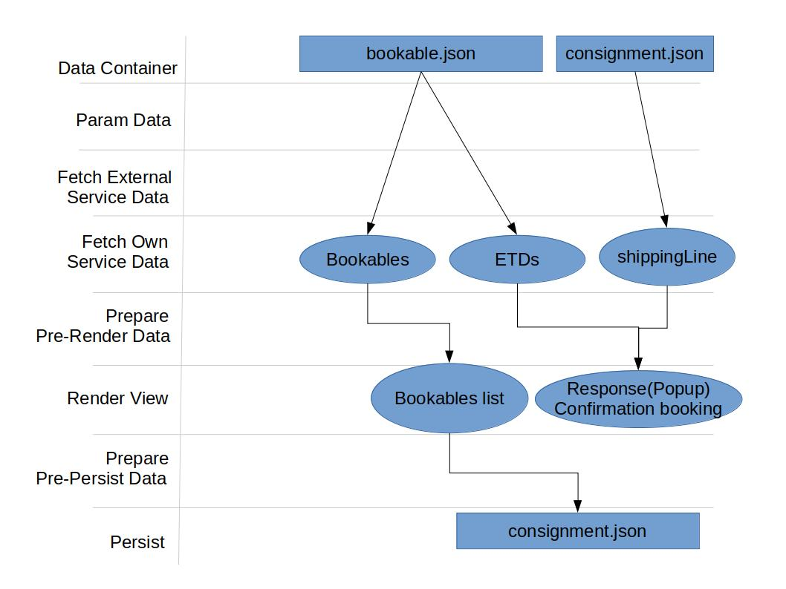

3.8.2 Operation Flow ( Confirm Booking)
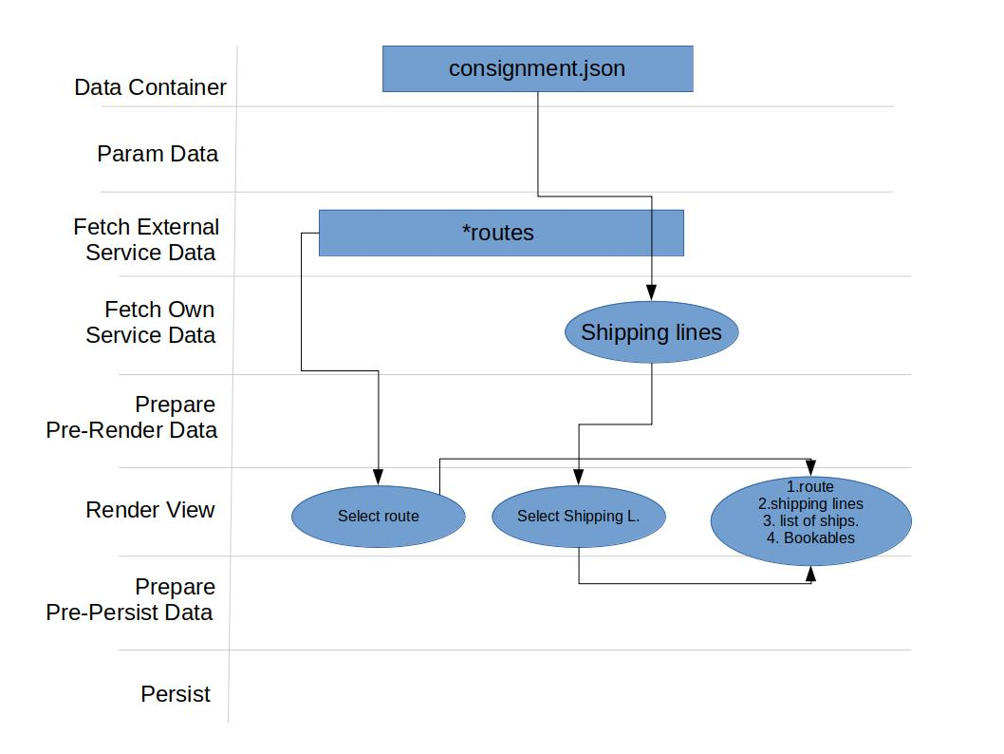

3.8.3 Operation Flow ( Containers)
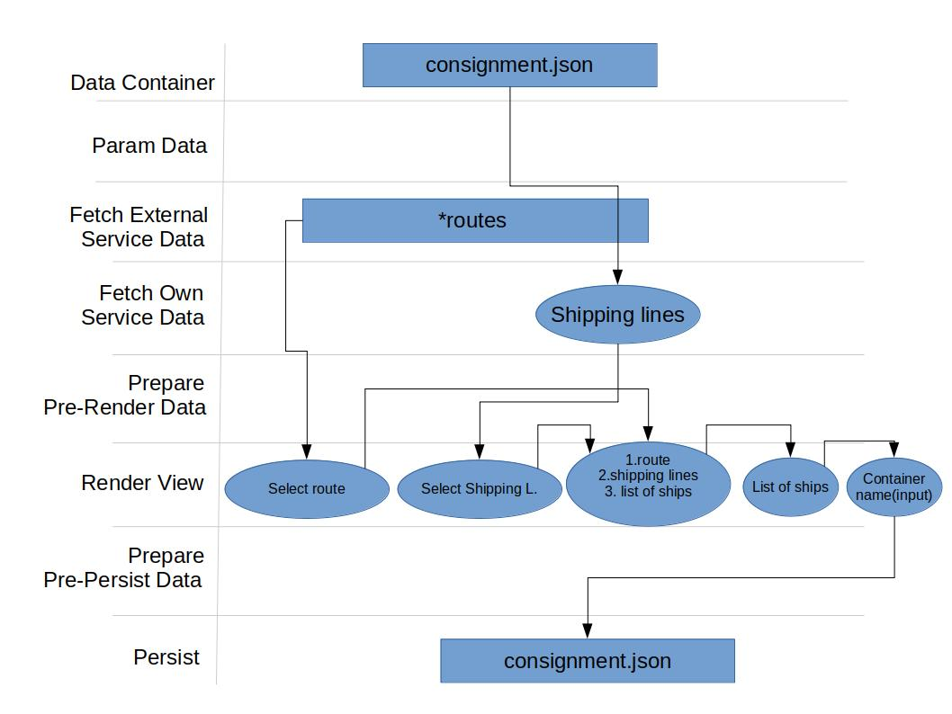

3.9 Data and Data Save Path ( Consignment Booking)
Task : Consignment Booking
JSON : consignment.json
- Path : /[id]/ fclContainer
- Path : /[id]/lclContainer
Sample Data :
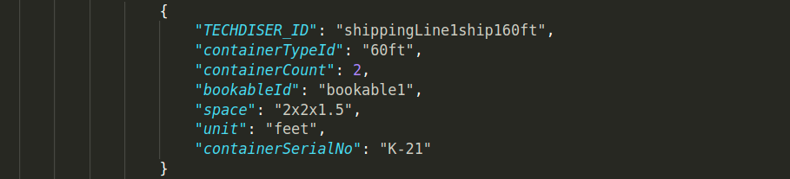

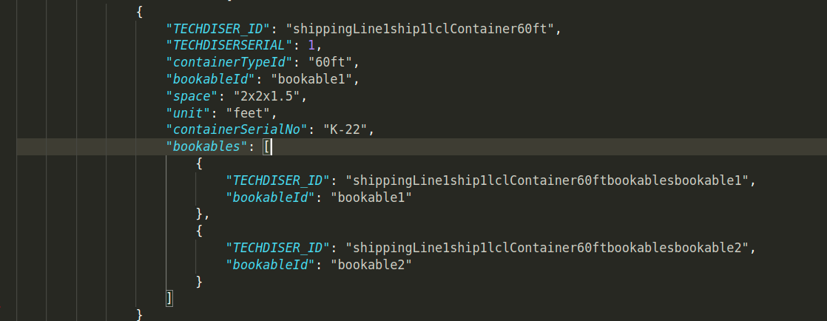

3.10 Technical Workout ( Consignment Booking)
Workspace | Components/Controllers | Data fetch | View data  preparation | Event/Operations | In-memory/save  data
Booking →  Confirmation | List of bookables (Info menu) | 1.bookable.json/[id]/ | View data preparation for list of bookable |  | In memory
Booking →  Confirmation | Confirmation booking response | Consignment.json/[id]/ | View data preparation for Confirmation booking response | Viewing response
Booking →  Confirm Booking | Select route(popup) | 1. *route | View data preparation for route | Select route
Booking →  Confirm Booking | Select shipping line(drop down) | 1.consignment.json/[id]/ | View data preparation for shipping line | Select shipping line
Booking →  Confirm Booking | Select container type(popup) | 1.*containerType | View data preparation for container type | Select container type
Booking →  Confirm Booking | List of ships | consignment.json/
Booking →  Confirm Booking | List of bookable | consignment.json/[id]/bookables
Booking →  Container | Select route(popup) | 1. *route | View data preparation for route | Select route
Booking →  Container | Select shipping line(drop down) | 1.consignment.json | View data preparation for shipping line | Select shipping line
Booking →  Container | Select container type(popup) | 1.*containerType | View data preparation for container type | Select container type
Booking →  Container | List of ships | consignment.json/
Booking →  Container | bookable | consignment.json/[id]/bookables
Booking →  Container | List of FCL containers | consignment.json/[id]/fclCOntainer |  |  | consignment.json/fclCOntainer

Chapter 4 : Consignment Create
4.1 Steps and Sub-Goals: (Consignment Booking)
SN | Tasks | Sub-Goals | Section
 | - Production confirmation | Production confirmation | Section- 4
 | - Consignment create | Consignment creating | Section- 4

4.2.1 Consignment Create →Production UI
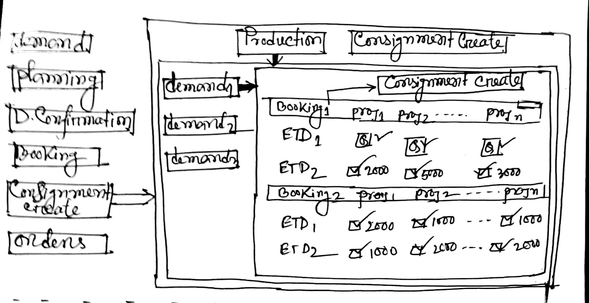

4.2.2 Consignment Create →Consignment Create UI
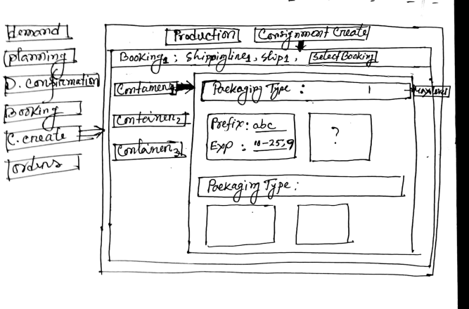

4.3.1 UI Routing (Production)
- Consignment Create(Menu) →Production (Tab)
4.3. UI Routing (Consignment Create)
- Consignment Create(Menu) →Consignment Create (Tab)
4.4.1 Production Confirmation Tasks (Production Tab)
- List of demands
- List of bookings
4.4.2 Consignment Create Tasks(Consignment Create Tab)
- Select bookable
- List of container for a particular bookable
- Packaging type
- Input packaging serial number

4.5 Expression Table
SN | Title | Content
 | External Dependencies | *routes, * projects
 | Business Constraints | - Max packaging type for consignment creating
 | Technical Constraints
 | Functions
 | Findings
 | Unexplored Issue
 | Deliverable
 | Notes

4.6 Data Structure
4.6.1 Mock Data
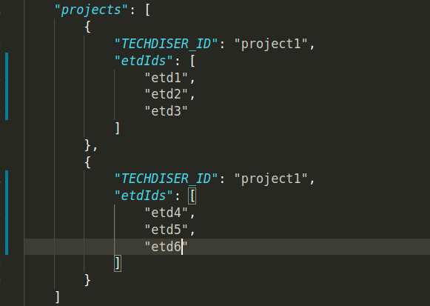

4.7 Derivation:
View Component | UI Routing | Json | Path
ETD-project matrix | Consignment Create →  Production | 1.* projects  2. bookable.json | 1.* projects/  2. bookable.json/
Container list | Consignment Create →  Consignment Create | consignment.json/ | 1.consignment.json/[id]/fclContainers  2.consignment.json/[id]/lclContainers
4.8.1 Operation Flow ( Production)
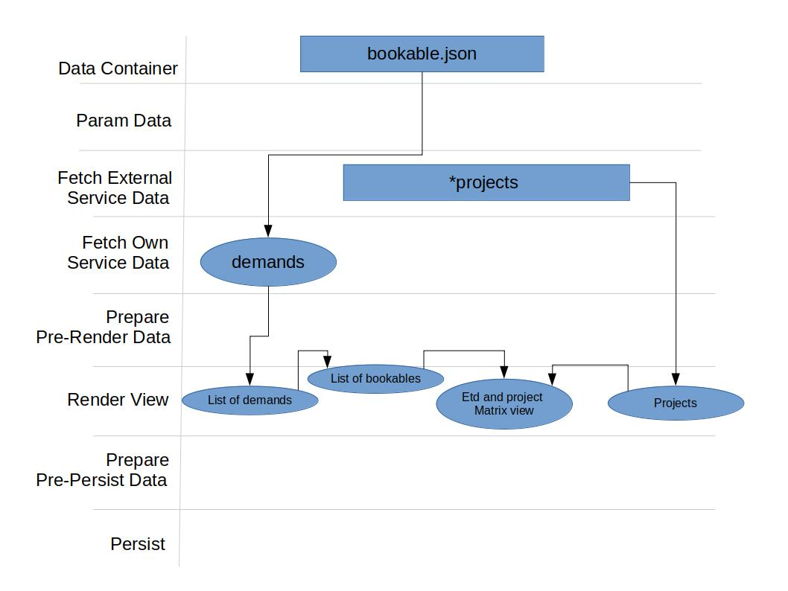

4.8.2 Operation Flow ( Consignment Create)
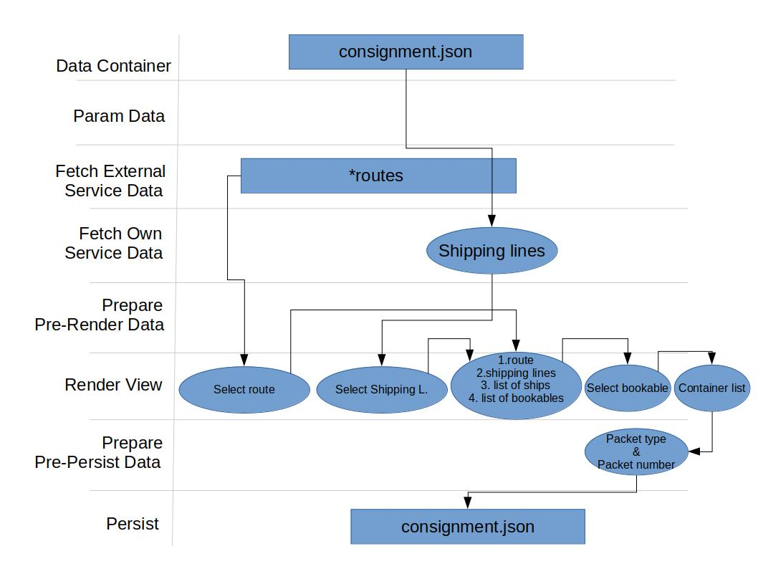

4.9 Data and Data Save Path
Task : Consignment Create
JSON : consignment.json
- Path : /[id]/lclContainer
- Path : /[id]/lclContainer
Sample Data : >>>>
Task | Path | Sample Data
Consignment Create | consignment.json/[id]/fclContainer/packaging;  consignment.json/[id]/lclContainer/packaging | 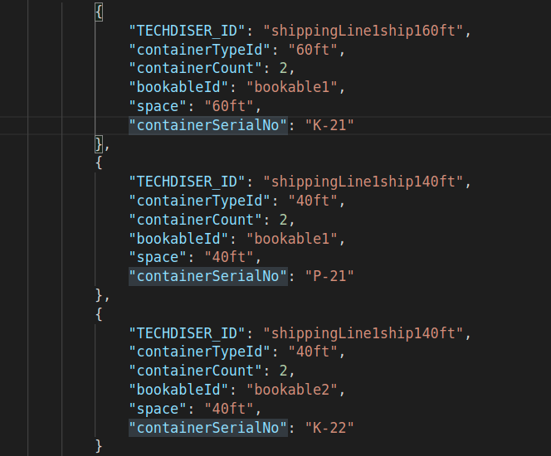

4.10 Technical Workout ( Consignment Booking)
Workspace | Components/Controllers | Data fetch | View data  preparation | Event/Operations | In-memory/save  data
Consignment Create →  Production | List of demands (Info menu) | 1.bookable.json/ | View data preparation for list of bookable | None | In memory
Consignment Create →  Production | Bookable list | 1.bookable.json/ | View data preparation for list of bookable | None | In memory
Consignment Create →  Production | ETD-project matrix | 1. * projects  2.bookable.json/ | View data preparation for ETD-project matrix | None
Consignment Create →  Consignment Create | Select route(popup) | 1. *route | View data preparation for route | Select route
Consignment Create →  Consignment Create | Select shipping line(drop down) | 1.consignment.json/[id] | View data preparation for shipping line | Select shipping line
Consignment Create →  Consignment Create | Container list | 1.consignment.json/[id]/fclContainers  2.consignment.json/[id]/lclContainers | View data preparation for container type | Select container type
Consignment Create →  Consignment Create | List of ships | consignment.json/
Consignment Create →  Consignment Create | List of packaging type | 1.consignment.json/[id]/fclContainers/packaging  2.consignment.json/[id]/lclContainers/packaging |  | Packing serial no input | 1.consignment.json/[id]/fclContainers/packaging  2.consignment.json/[id]/lclContainers/packaging

